**Scenario 2: “Immersive Data Visualisation”**

# Abstract

This report uncovers the use of advanced data visualization resources such as network diagrams and Tableau to uplift the processes of data analysis and interpretation for complex data, illustrating with the example of a passenger flight dataset which attributes includes AirSpace class, From_City, To_City, Price, Aircraft Model, and Engine Model. Along these lines, the graphical representation of raw data into convenient formats contributes in improving people interface and easy comprehension of complex connections and dependencies between the information. Network maps are a visual tool to show the connectivity and volume/amount of traffic between cities, which are indicated by the edges that are either directed or undirected to point out significant pathways and network density. Tables offering different graphical representations such as pie charts, bar charts, and flow maps among others, allow users to interact with the data and easily spot trends or outliers, in Taleau, commonly used for data analysis purposes. Interactive displays of such visualizations, for example, hovering and clicking, increase the engagement of a user and help with decision-making with the simple actions that enhance cognitive ability. However, increasing transparency, data comprehension, and more confident choices also show that visualization tools have a vital role in modern data analysis and interpretation.

Table of Contents

Abstract 2

Introduction 4

Network Graph 4

The Data Visualisation 5

The Collection and the Storage of Data 5

The Interpretation of Data 6

The Exploration of Data 6

The Data Storage 7

The Navigation Schemes 10

Conclusion 11

References 13

# Introduction

Through a variety of available visualization tools, we can get a better understanding of the data by depicting data in different forms such as charts, bars, graphs, etc. The data given in the flight dataset consists of six attributes – AirSpace class, From_City, To_City, Price, Aircraft Model, and Engine Model [1]. Representing six main phenomena [of a country's economy] is hard, and this can be achieved with the interactive methods of graph visualization.

For instance, we can make simulators as a map or diagram of a network. This method is the best option for the preferred presentation of the provided dataset.

## Network Graph

To illustrate this type of metaphor, we can also see the code presented in the below section. It exhibits interdependency among two or more entities with the nodes or vertices and a link or line is used to tell them that run directly to each other. There are various types of the route info line. Some of them have directions that also describe how one area is related to another part of the neighborhood.

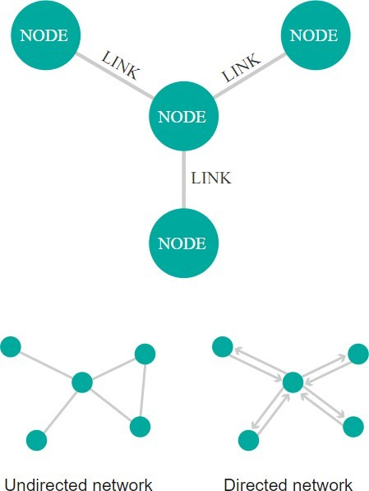

Figure 1: The Network Diagram/ Visualisation

The nodes are drawn with a circle or ellipse and the link between two circles can be shown by a line. Network Maps mean visualization and are often easy to understand [2]. It decided where a link was to be between the different nodes in this formation. Also, it indicates which nodes have huge traffic and hence are busy in this scenario. The Network map diagram illustrates two types of connecting lines - line 1. Undirected 2. Directed.

1. Unidirectional – In the sort of Network map that has a base, the lines only show the connection between two nodes. It specifies two nodes by a line and says they are connected.

2. Directed – Concerning the undirected edge, it is a bit complicated type and it is useful for the network in which the direction of the link between 2 nodes is essential. Helping you out, if required, I will demonstrate you can represent a one-way or two-way link using a directed network graph [3]. It is performed by using arrows on the top part of a sentence. Moreover, the flight data likely would be represented in this way as much as the arrows would show the direction of flights (to or from).

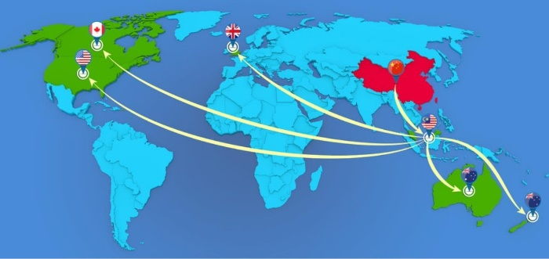

Figure 2: Directed Network Map and Visualisation

The degree of network density is what matters when it comes to assessing the health and effectiveness of a network. This goes beyond the sheer number of connections in the network and focuses on the fact that some links and nodes in the network are more heavily trafficked than others. When contact density is examined, lots of details about the network are revealed. Helplessness of observations regarding the growth or deterioration of figures, next, could be detected via utilization of (Rosenblatt 2013).

Observing the diagram, the nodes are sparsely connected, as the number of the points connected is much lower than the total possible points that can be linked.

If n= total number of nodes, G = total number of edges.

Complete amount of all possible connections (Rosenblatt 2013) = n (n –1) /2

= 20 = ((20 − 1) ÷ 2) = 20

= 20 (19) ÷2

= 380 ÷2

= 190

We divide it into 2 because a line or edge has 2 endpoints and thus, performs the task of linking 2 nodes.

The number of edges that are given in the table is 48.

As a result, the Density percentage of the given dataset = 0. 439393939394. 2,520/1,000 = 25%

# The Data Visualisation

## The Collection and the Storage of Data

Data recording, however, is the most important, so finding the existing resource helps a lot [4]. The data can be stored in various formats, for eg: XSL, XLSX, and CSV format. The data is investigated using a visualizing tool to create an appropriate illustration.

The tables of data have already been sent to us in PDF format for this purpose. Subsequently, I transfer the information into Excel format to give the visualization tool a more readable and usable format [5]. Once it has been done, data is exported and added to Tableau, the data visualization tool.

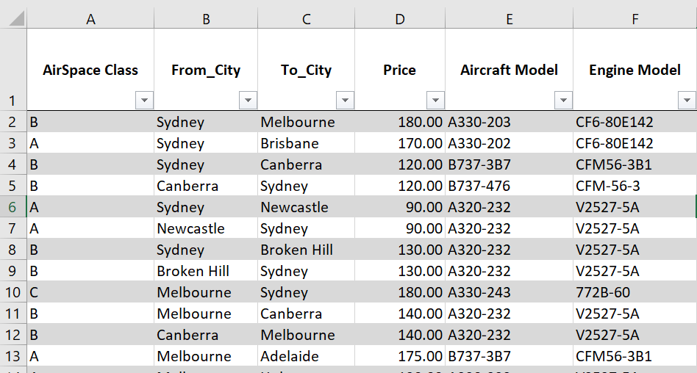

Figure 3: The Data Collection

## The Interpretation of Data

This data is airline flights that interconnect to various cities in Australia. The flight data set given for this task consists of 48 rows and 6 columns with their size and dimensions.

The six columns are:

1. Class Of AirSpace – This attribute signifies the kind of airspace. The five different classes of the air space are A, B, C, D, and E represented by A, B, C, D, E. The air routes of the world are divided into three-dimensional (3-D) sections including control, reservation, and flow management. The next suggested part mentions a class of airspace for each class.
2. from_City – Flight_path, this tag shows the distinct heading of the flight. It records the place from which the plane starts.
3. cTo_City – fr From_City – This line shows the essence of flight. It indicates just the name of the city of arrival.
4. Price tag – This element displays the price of the tickets for a flight in Australian Dollars.
5. Aircraft Model – Interestingly, this column depicts the model of Aircraft.
6. Engine Model – This parameter is used for the menu user interface. Users can select the engine model of their aircraft.

## The Exploration of Data

As the 'collection' phase is over, we can now export the data to the Tableau visualization platform which is a very powerful tool. You can explore the data in Tableau even more thoroughly and uncover other cool facts that will amaze you. This is useful in making presentations to the users, which would be recognized easily.

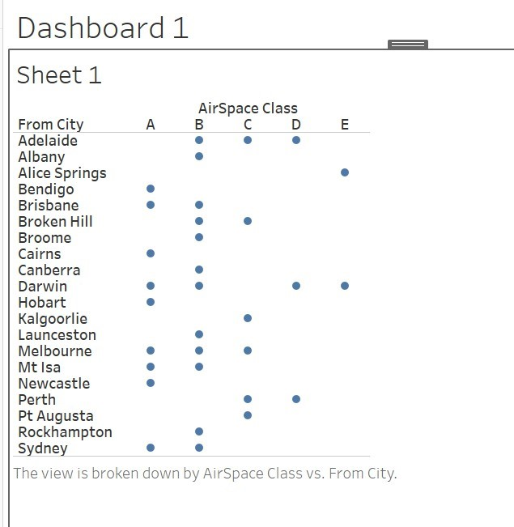

Figure 4: A bar graph is created to compare the properties of "From_City" and "Price".

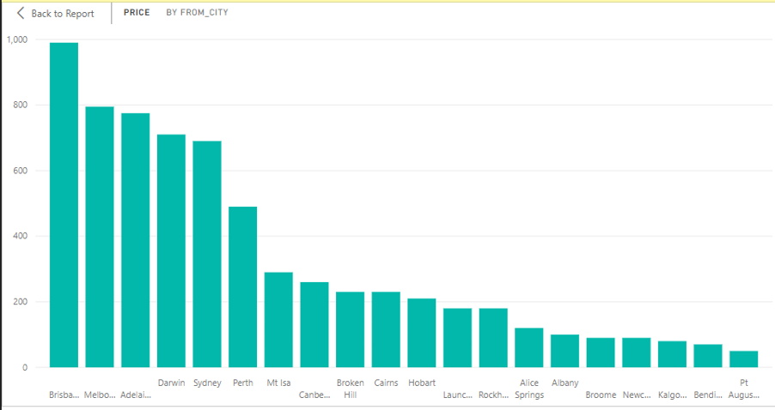

Figure 5: A bar graph is created to compare the properties of "From_City" and "Price".

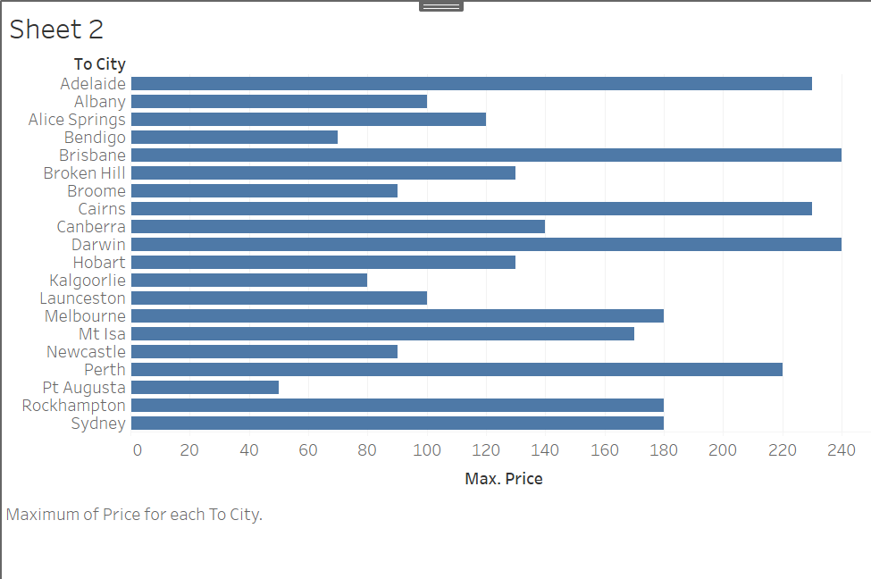

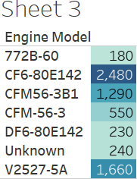

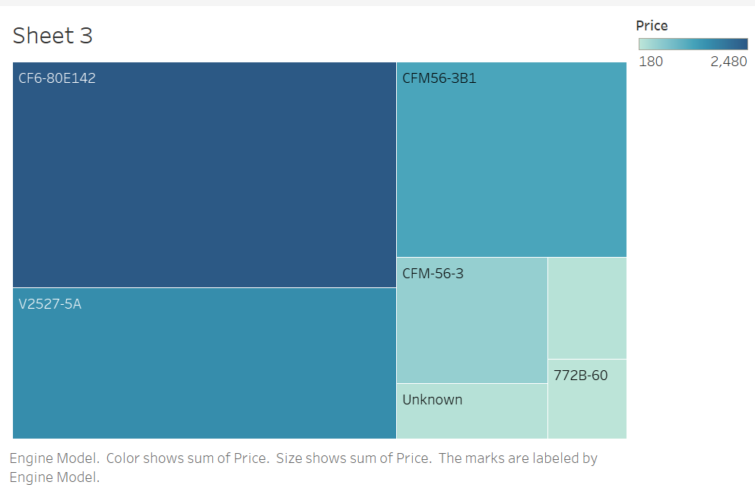

This is an interactive website that gives the best knowledge in the form of data [7]. Such visualization enables a user to give meaning to the presented data. This will happen when the user takes their cursor on the boxes, and it will be represented as the value of the sum of prices that are associated with the particular engine model being used.

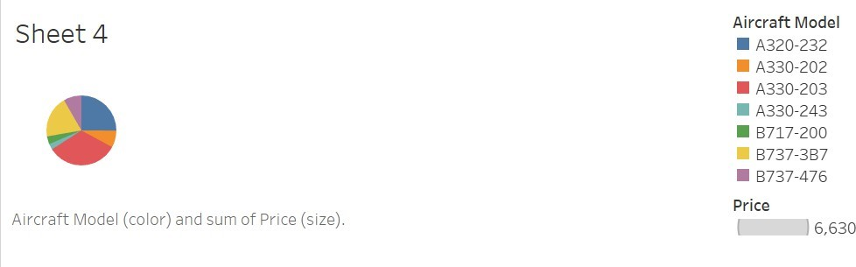

Below you can navigate a visual pie chart showing the relationship between the Aircraft model and the sum of prices. When the user will be hovered over this part of the circle, it will show the hardware price sum as well as the model.

# The Data Storage

Once visualization has been created, open Tableau to save the data and also save the Excel file which has been exported to Tableau to enable reuse and reference in the future.

In the examples of data presentation, I have depicted the given details with the aid of the colored boxes, the bar graph, as well as the tables, the pie chart, and the colored tables. I used Tableau for visualization to create the graphs [6]. The point coordinates on the map are different and individual, there is no cross-lap with the edges. Clips that are the property of a single airline have the whole database represented in a single view. Anchor interaction modeling, so any city when you point to there, the details of that airline and the flight time will displayed to the user, and then the edge crossing problem disappears.

This is only because the distances at the localities with various longitude and latitude are with no level of intersection.

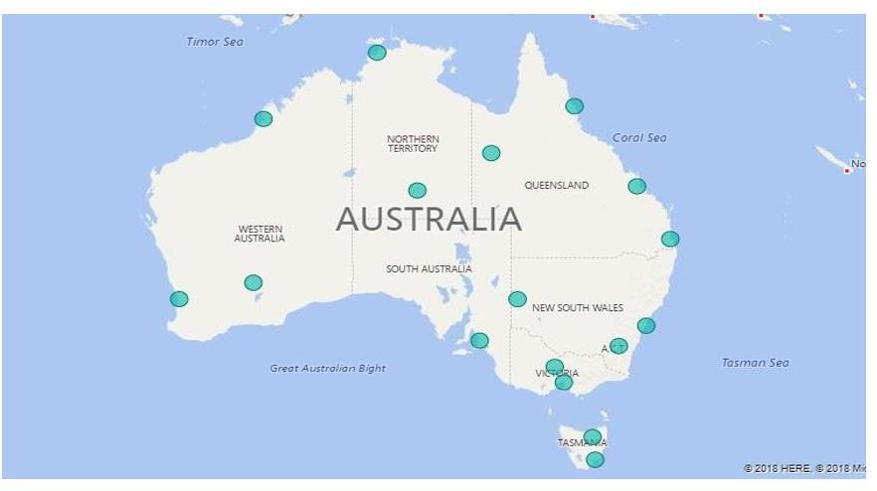

The information about departure, arrival connecting flights, etc, has all been mapped with a personalized view on the user interface map. This proved the logic of showing the flight lines where the text became clearer for the user [8]. What we want to do as an example - the cursor will be placed in one of the cities from the hidden cities list and the target city will be colored and selected by us. In the case of this one, we have followed the blue color.

What could have achieved a substantial advancement in data visualization was the implementation of visualization instead.

The applicability of graph drawing rules to the legibility of the graph's layout is another area where aesthetics can be utilized. The Aesthetic rules of graph drawing are: The Aesthetic rules of graph drawing are:

1. The emphasis on symmetry will be a key tip to organizing the layout.
2. In the matter of colors, use those that are alike but separated as well.
3. The recommended nodes should be crowd-free and there should be as uniformly distribution as possible of these nodes in a two-dimensional plane.
4. Labels should be strictly visible and comprehensible for the user with a meaning and clear that can be easily read.

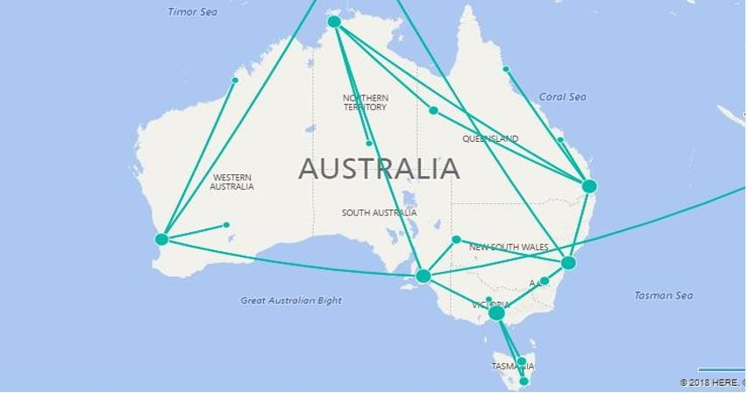

* The two circular nodes named the cities of the starting and ending cities of a flight are shown on the design.
* The node under it appears if you run your cursor on it and will display the city name.
* The user will have the option to choose an airline if he/ she wishes to. When the particular airline is chosen, the flight information of that particular airport will be shown.
* Explanation of the pie chart is price distinction.

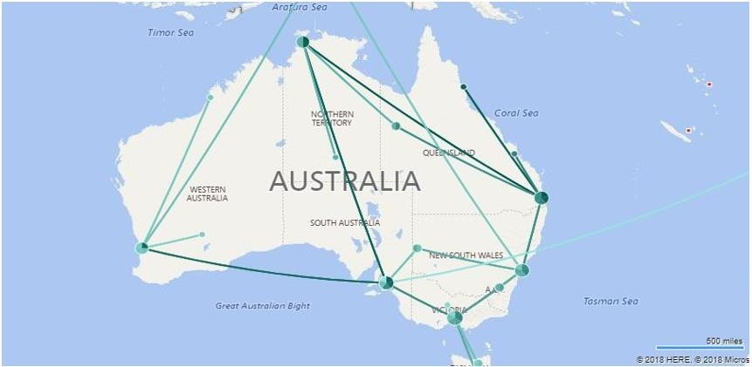

***Graphic objects design:***

The design is running in a graph as the layouts. The figure indicates the different values of prices with a pie chart, a flow map that shows the flight routes, and nodes which mean the cities. To make it easier for the user, simplicity should be the design prerogative of every object.

Not only scales, but graphics' attributes also work by correcting their positions (and partitioning).

**Color:** Representation of scale and details are represented by a variety of colors in the design. Each fragment of color in the pie chart denoted one of the 5 alleys towards airspace. You can craft distinct airspace classes from the selection of various colors for class A, class B, class C, class D, and class E.

In the bar graph, colors are applied which show the difference between aircraft and engine types of different models with their prices [9]. Thus, with the kind of flight detail, it can be found out which one is the most ideal.

**Lines:** The flight operation that is shown by flight lines includes information such as flight route, arrival, departure time, arrival time, etc.

**Pie chart:** A discrete pie chart to represent the different airspace classes and price ranges can be employed. It shows how much precis one will pay for this destination tour in the budget taken into consideration.

**Icons:** Node represents the cities, which are portrayed with these objects [10]. The nodes are represented by the circular icons depicted in the visual diagram. If the cursor is currently showing a certain route ID, then the related node will appear shaded. Through this approach, it becomes more comfortable to plunge into the map of the route and to elucidate the path details.

**User interaction:** I visualize the dashboard using react libraries for user interactivity only [11]. A mouse click has a mouse positioned such that it will display city names.

As the user hovers the cursor of the mouse on any line, the cities other than the ones on this line will get greyed out. The one on the hovering user will appear in blue, which helps the user to spot the desired flight details.

The moment the user attempts to navigate and selects a specified airspace pie chart, all the features including price, aircraft models, and road and engine type of class A will display [13].

Addressing the complexities of custom-fitting visual properties to the corresponding domain-specific attributes is the core task.

Multiple blacks are coming with Tableau and as a result, by using these blacks, we can visualize complicated figures from various specific domains as graphic images.

To represent the trip data and location, I have used To_City and From_City attributes and flow maps [14]. Complicated patterns are created by the arrangement of different colors and shapes. Pie graphs, donut charts, bar charts, and so on are used to match the specific domain for which we are visualizing the attributes in a graphical nature.

Addressing the dataset scale problem, essentially the computational cost that entails running this chosen layout algorithm.

Playing the role of a primary hub of communication, the tableau connects all nodes to a single node, so the algorithm has the lowest computational cost at the stage of implementation. In subsequent calls for this algorithm, of course, this is not required.

The quantity in equations that are required to serve the layout is the basis of the computation cost. The more equations, the more expensive the learning process becomes.

**What things should I do to increase the frequency of attributes specified for a domain?**

The ability to portray the domain-specific features even more readably can be enhanced using the tools that render data in the form of graphics. When the data is replaced by graphical immersions, the user views judgment, and understanding of information presented clearly, a in detail [12]. One of the cautions is unusual colors, and this could aid in readability. Tableau can visualize flight information in different layers, as provided by the platform.

## The Navigation Schemes

***There are two navigation techniques and they are:***

1. Mouse over event: In this navigation type, the user moves the cursor in the mouse direction and lays down on the flight line, there will be information relating to that flight is shown [15].

The user clicks on To_City and From_City buttons where one then gets into departure and arrival details.

One more thing (the last point) is that the user can easily review the finished design by simply clicking anywhere on the tool.

1. Filtering – it is possible to apply this tool in the visualization to be able to make the user interface simple and easy to use. Using the graph types we can show the price difference thereby making them implementable as well.

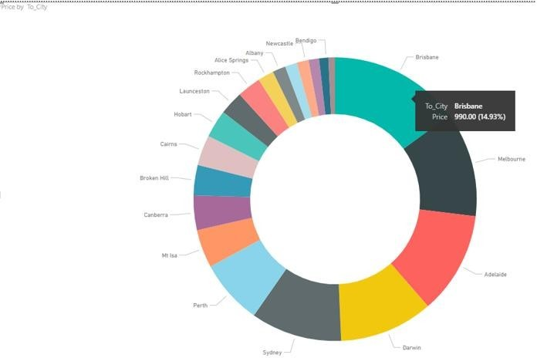

# Conclusion

In conclusion, mixing the use of network graphs and Tableau software with data analysis techniques turns out to be an incredible innovation that greatly boosts our capacity to comprehend and interpret complex data sets such as the flight dataset. This data set, for instance, consists of characteristics like AirSpace class, From_City, To_City, price, Aircraft model. and engine model. benefits greatly from the other visual presentation formatswork graphs are a powerful tool to help visualize the interactions and connections between nodes represented as cities by labelling the line arrows represent directions and the thicknesses of the arrows represent the strength of the linkages given this network can depict the busy routes and assess the wellbeing of the network. The procedure commences with the data collection and its storage in formats like XSL, XLSX, and CSV. Secondly, the data is converted to Excel and again converted to a . csv format from Excel, and the data is uploaded to Tableau where data science is analyzed through sophisticated tools such as graphs and maps. Tableau‘s capabilities are comprehensive enough to support the presentation of numerous forms, among them pie charts, bar graphs, and flow maps, increase data complexity understandability, and create an intuitive interface for interactivity from the user end. Another feature that I love is the one where users can use a pointing device to point at an element and the hover state reveals more information about that element so understanding and retaining new concepts become much easier. Thus, graphs of the network are significantly used as they showcase chains of unidirectional and bidirectional links between nodes which are fundamental for portraying the flight paths and directions between cities, particularly in grasping the design and dynamics of global air travel networks. Nodal and edge counts of the network using the density formula explain the lack or density of connections that assist in the optimization of routes and improve the network’s efficiency. But the main factor that differentiates these visualizations from conventional graphs is the interaction with users, which helps them to navigate through data by hovering their mouse over specific items, clicking to be able to narrow down the information or choose specific features therefore making it possible for users to take more informed decisions. As an example, flight cost comparison and top-rated aircraft models' use are two features that are immediately recognizable by the users.

Visual representation technique facilitates recognition of visual patterns and visual abnormalities that may fail to be spotted by the estate in raw data and their place color coding, different shapes, and interactive elements ease comprehension even with the most complex data. As an illustration. pie charts could complete the distribution of various airspace classes, while bar graphs present the price differences for choice aircraft. Moreover, data visualization with sophisticated graphs such as networks and Tableau brings new views and practical interpretation of the data, making it simpler and more accessible, leading to more in-depth analysis, and eventually the development of smarter decisions. The fact that visual exploration of data is a feature that is combined with interactivity is conspicuous and it proves the importance of these tools for the analysis of data in the present-day tech era as data is now more accessible understandable and conveniently manipulatable to extract data towards which informed decisions are based on sufficient evidence.

# References

1. B. Söderlund, “The importance of business travel for trade: Evidence from the liberalization of the Soviet airspace,” *Journal of International Economics,* vol. 145, p. 103812, Nov. 2023, doi: https://doi.org/10.1016/j.jinteco.2023.103812.
2. J. Li, F. Goerlandt, and G. Reniers, “An overview of scientometric mapping for the safety science community: Methods, tools, and framework,” *Safety Science*, vol. 134, p. 105093, Feb. 2021, doi: https://doi.org/10.1016/j.ssci.2020.105093.
3. G. Boeing and W. (Billy) Riggs, “Converting One-Way Streets to Two-Way Streets to Improve Transportation Network Efficiency and Reduce Vehicle Distance Traveled,” *Journal of Planning Education and Research,* p. 0739456X2211063, Jul. 2022, doi: https://doi.org/10.1177/0739456x221106334.
4. S. Christin, É. Hervet, and N. Lecomte, “Applications for deep learning in ecology,” *Methods in Ecology and Evolution*, Jul. 2019, doi: https://doi.org/10.1111/2041-210x.13256.
5. J. Li et al., “*Hiplot: a comprehensive and easy-to-use web service for boosting publication-ready biomedical data visualization*,” vol. 23, no. 4, Jul. 2022, doi: https://doi.org/10.1093/bib/bbac261.
6. S. Batt, T. Grealis, O. Harmon, and P. Tomolonis, “Learning Tableau: A data visualization tool,” *The Journal of Economic* *Education*, vol. 51, no. 3–4, pp. 1–12, Aug. 2020, doi: https://doi.org/10.1080/00220485.2020.1804503.
7. K. Syauqi, S. Munadi, and M. B. Triyono, “Students’ Perceptions toward Vocational Education on Online Learning during the COVID-19 Pandemic,” *International Journal of Evaluation and Research in Education*, vol. 9, no. 4, pp. 881–886, 2020, Available: https://eric.ed.gov/?id=EJ1274581
8. D. Gritsenko and M. Wood, “Algorithmic governance: A modes of governance approach,” *Regulation & Governance*, Nov. 2020, doi: https://doi.org/10.1111/rego.12367.
9. “Visualization of Business Intelligence Insights into Aviation Accidents - ProQuest,” *www.proquest.com.* https://search.proquest.com/openview/1a5fbb69c4ec340886d75c516799bfc2/1?pq-origsite=gscholar&cbl=5444811 (accessed May 19, 2024).
10. G. Filomena, J. A. Verstegen, and E. Manley, “A computational approach to ‘*The Image of the City,*’” Cities, vol. 89, no. 89, pp. 14–25, Jun. 2019, doi: https://doi.org/10.1016/j.cities.2019.01.006.
11. S. Hossain, “Visualization of Bioinformatics Data with Dash Bio.” *Accessed*: May 19, 2024. [Online]. Available: https://pdfs.semanticscholar.org/9d0f/d60653943641935db30692c1019aa9b22fa8.pdf
12. B. Lee, D. Brown, B. Lee, C. Hurter, S. Drucker, and T. Dwyer, “Data Visceralization: Enabling Deeper Understanding of Data Using Virtual Reality,” *IEEE Transactions on Visualization and Computer Graphics*, vol. 27, no. 2, pp. 1095–1105, Feb. 2021, doi: https://doi.org/10.1109/TVCG.2020.3030435.
13. E. Trevisin, “A policy-sensitive high-level model for comparison of emission and cost reduction options for aviation : techno-economic model for zero emission aviation in Norway,” *openaccess.nhh.no*, 2021. https://openaccess.nhh.no/nhh-xmlui/handle/11250/2772262 (accessed May 19, 2024).
14. J. Qin, C. Song, M. Tang, Y. Zhang, and J. Wang, “Exploring the Spatial Characteristics of Inbound Tourist Flows in China Using Geotagged Photos,” *Sustainability*, vol. 11, no. 20, p. 5822, Oct. 2019, doi: https://doi.org/10.3390/su11205822.
15. A. Molina, J. A. Castro-García, F. Gómez-Bravo, R. López-Ahumada, Raúl Jiménez-Naharro, and S. Berrazueta-Alvarado, “*Controlling a Mouse Pointer with a Single-Channel EEG Sensor*,” Sensors, vol. 21, no. 16, pp. 5481–5481, Aug. 2021, doi: https://doi.org/10.3390/s21165481.